**u|Lg ;f];fO6L klAns :s'n**

**D- 22**

**/Tggu/–&, ;f}/fxf lrtjg**

**k|yd q}dfl;s** परीक्षा**—@)*@**

**sIff M– o"= s]= hL= समय - @ 3+=** **k"0f{fÍM– %)** **ljifoM– g]kfnL**

|  |
| --- |
| **gfd : ====================================================/f]n g+=============;]S;g M ================** |
| **_________________________ ______________________ s'n k|fKtf**Í **:**  **lg/LIfssf] ;xL k/LIfssf] ;xL** |

**k|Zg g+= ! b'O{ cIf/n] ag]sf zAbx¿ n]Vg'xf];\ . -%_**

**k|Zg g+= @ tLg cIf/n] ag]sf zAbx¿ n]Vg'xf];\ . -%_**

**k|Zg g+= # …sÚ b]lv …sMÚ ;Dd qmd ldnfP/ hf]8\g'xf];\ . -%_**

**s ls s' s] sf] s+**

**sf sL s" s} sf} sM**

**k|Zg g+= $ j0f{ hf]8]/ zAbx¿ n]Vg'xf];\ . -%_**

**k|Zg g+= % bL3{ Osf/ -L_ nfu]sf zAbx¿df uf]nf] 3]/f nufpg'xf];\\ . -^_**

**/fgL dnd znud**

**6]an r/L h'gf/**

**Dffdf d;L emf]nf**

**hLjg df]6f] o1**

**kj{t j+z aL;**

**cfdf gfgL cfn'**

**k|Zg g+= ^ :j/ j0f{ / dfqf aLr hf]8f ldnfpg'xf];\ M -^_**

cf }

O{ ]

P f

c+ f}

cf} +

P] L

**k|Zg g+= & zAb agfpg'xf];\ . -^_**

-------------------------------- ------------------------------

-------------------------------- ------------------------------

-------------------------------- ------------------------------

**k|Zg g+= * lrq x]/]/ gfd n]Vg'xf];\ . -^_**

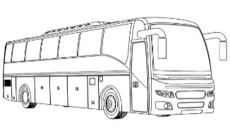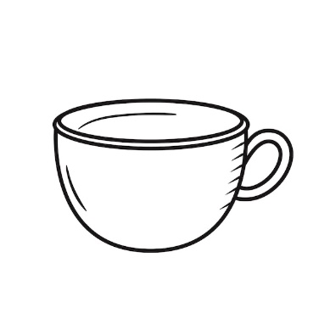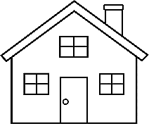

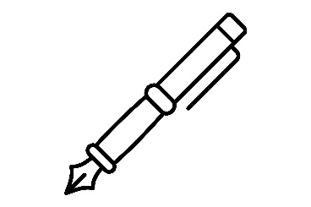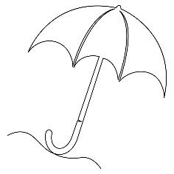

**k|Zg g+= ( zJbx? hf]8]/ jfSo agfpg'xf];\ . -^_**

lstfa ahfpm .

lx;fa k9 .

lutf/ u/ .

**;dfKt**